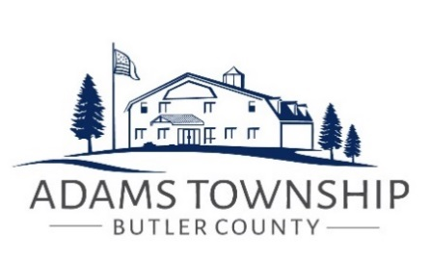

MEETING AGENDA
August 8, 2022

Opening of regular meeting
Public Comment
Approval of Minutes
Board of Supervisors Meeting – July 25, 2022

Departmental Reports

    - Public Works Department Report
    - Code Enforcement Officer’s Report
    - Engineer’s Report
    - Solicitor’s Report
    - Animal Control Officer’s Report
    - Police Report
    - Park and Recreation Report
    - Fire Department Report

Treasurer’s Report
Approval of Treasurer’s Report and payment of invoices
New Business
- Three Degree/ Valencia Road Phase 2 Bid
Adjournment

